plasma

timepoint=1

not “Stephen Cristiano”

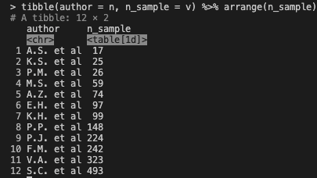

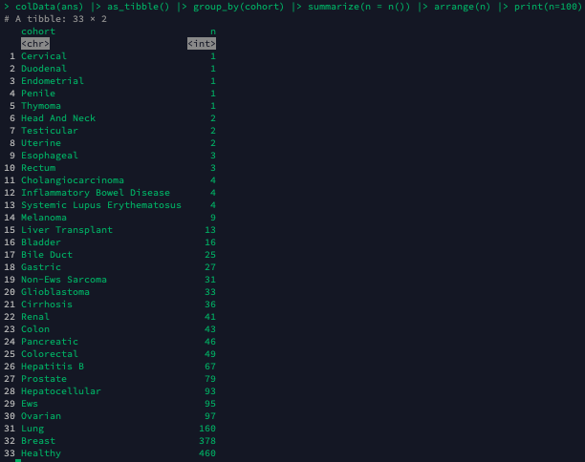

/home/nrlab/wang04/ulyses/explore_packaged/functions/ulyses_image_to_features.R

Line: 672

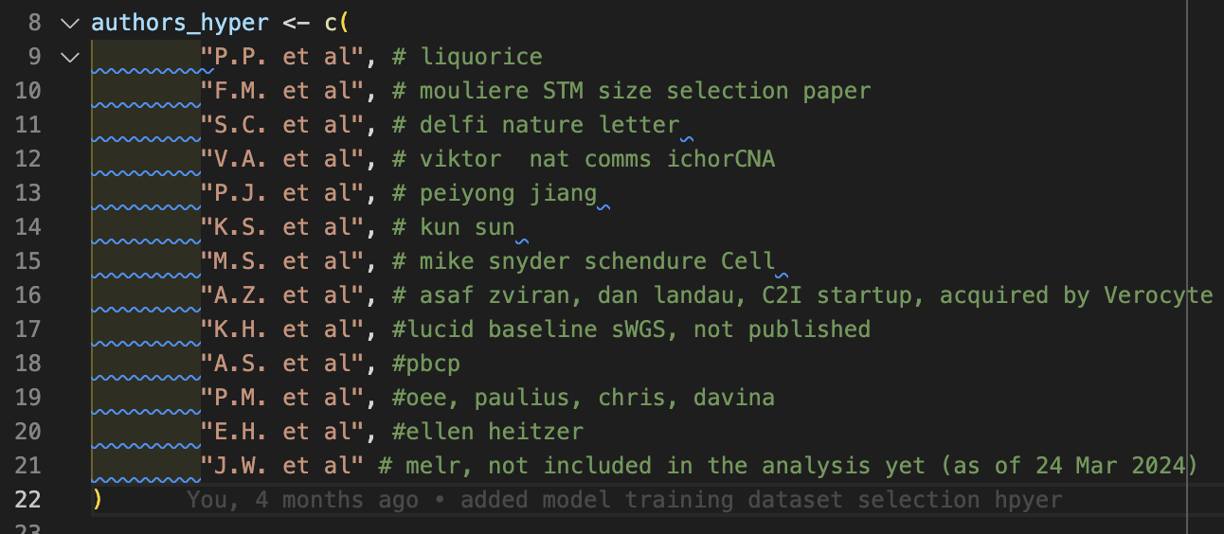

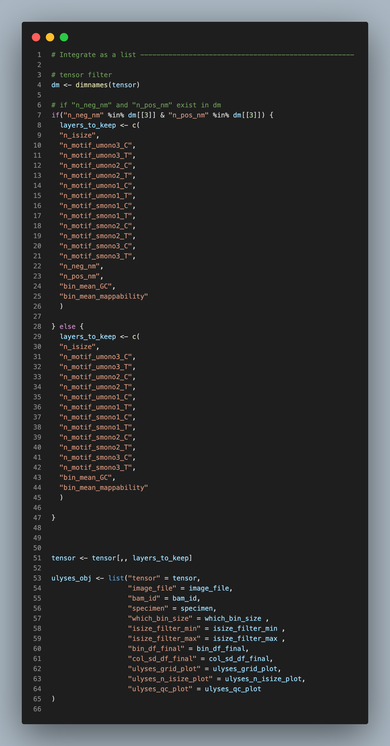

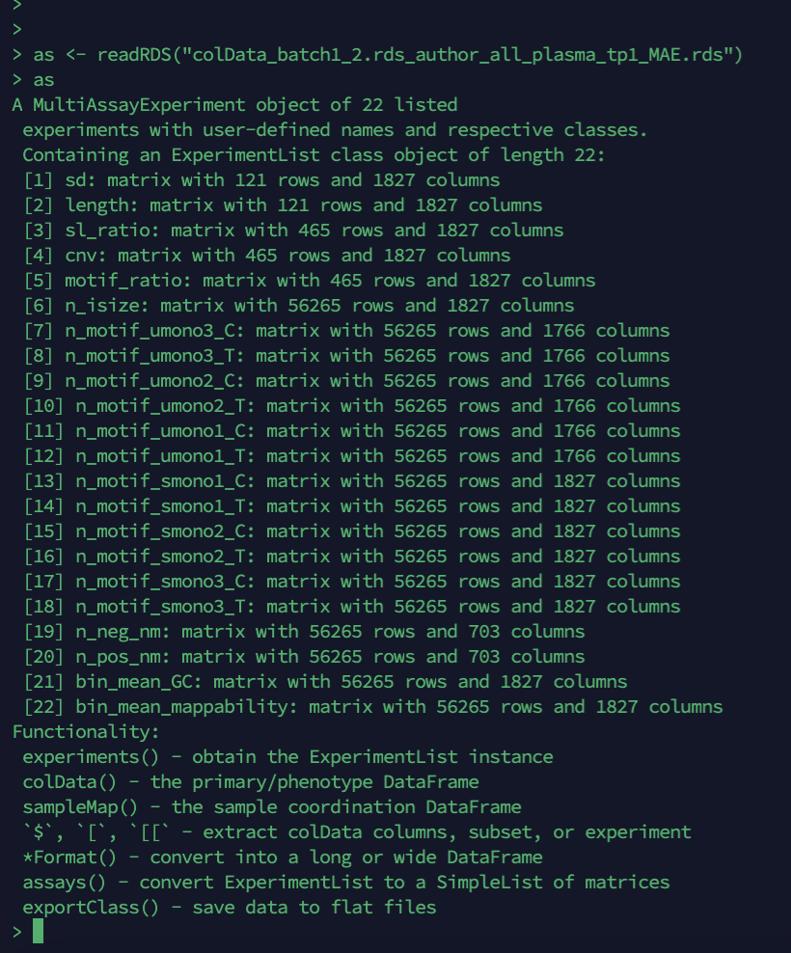

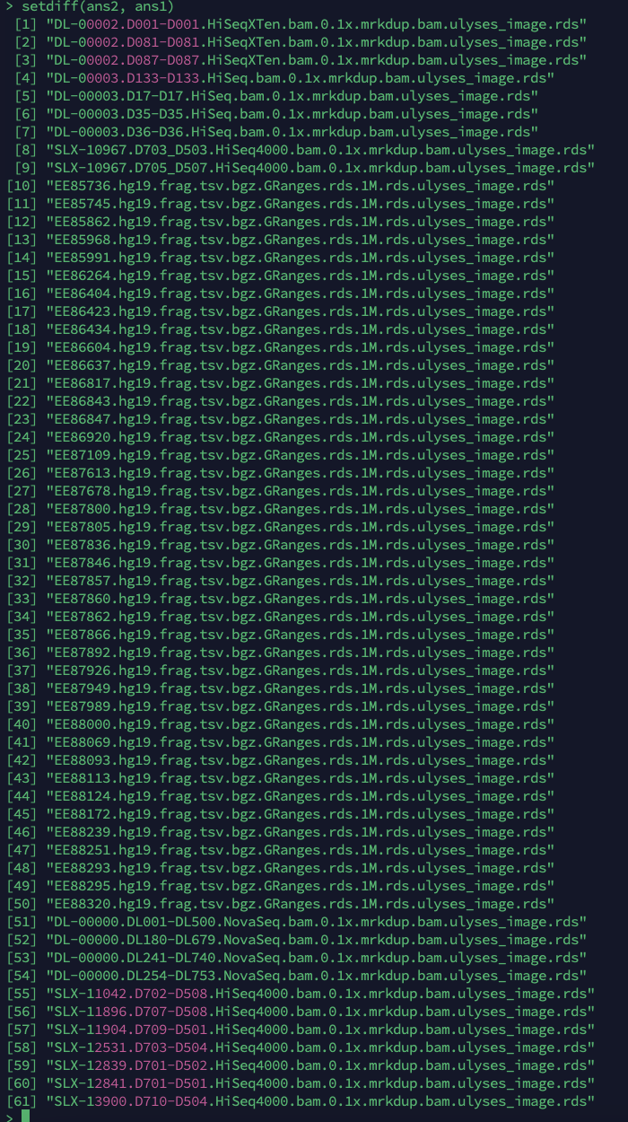

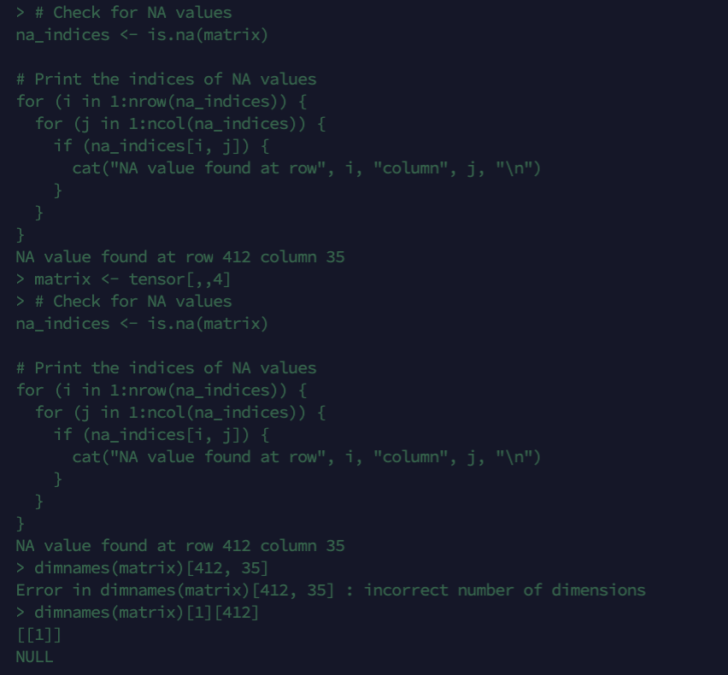

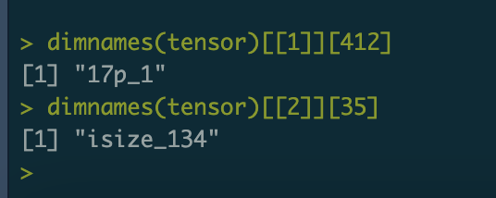

> setdiff(eh_more_names, eh_less_names)

[1] "DL-00003.D133-D133.HiSeq.bam.0.1x.mrkdup.bam.ulyses_image.rds"

[2] "DL-00003.D17-D17.HiSeq.bam.0.1x.mrkdup.bam.ulyses_image.rds"

[3] "DL-00003.D35-D35.HiSeq.bam.0.1x.mrkdup.bam.ulyses_image.rds"

[4] "DL-00003.D36-D36.HiSeq.bam.0.1x.mrkdup.bam.ulyses_image.rds"

